CONCORDi 2023
9th European Conference on Corporate R&D and Innovation
24-26 October 2023 – Seville (Spain)

Industrial innovation for Open Strategic Autonomy

Logistical Information
CONFERENCE VENUE

The conference will take place on the premises of the Building Cartuja Center Cite,

Calle Leonardo da Vinci, 7-9,

Sevilla 41092

https://cartujacenter.com/
Google Maps
Public parking is available onsite and costs 14.00 EUR/day.

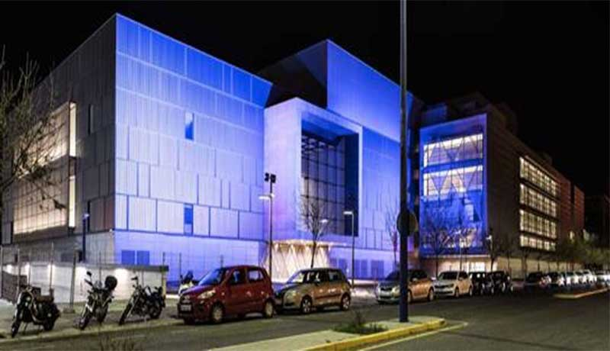

HOTEL INFORMATION
The following hotels are located relatively near the conference venue. All of them offer especial rates so please do not hesitate to tell them when you contact them for your reservation that you are attending a conference organised by the European Commission - JRC Seville.
Please, take into account that hotels are very busy in Seville in this period. We recommend you to book your hotel as soon as possible.
There are many other hotels and tourist apartments in the area surrounding the Conference venue; you are invited to enquire them as well.
Hotel | Category | Distance to conference venue | Contact details
Zénit Sevilla | 4 stars | Triana / 2.8 km | Miriam Mora +34 954 347 434  comercialandalucia@zenithoteles.com
Barcelo Renacimiento | 5 stars | Cartuja / 1.5 km | Tonia (+34) 910 78 53 96  sevillarenacimiento.res@barcelo.com
Ribera Triana | 4 stars | Triana / 2.2 km | Aurora Tejera  +34 954268000  reservas@hrtriana.com
NH Plaza de Armas | 4 stars | City centre / 1.8 km | Ana Gayoso  (+34) 954 901 992  nhplazadearmas@nh-hotels.com
Eurostars Torre Sevilla | 5 stars | Cartuja / 1.7 km | Cristina BUITRAGO  (+34) 954 466 022  reservas@eurostarstorresevilla.com
Hotel Monte Triana | 4 stars | Triana / 2.3 km | Jose Ángel DE AMORES  (+ 34) 954 21 75 01  hotel@hotelgravina51.com
Eurostars Regina | 3 stars | San Lorenzo / 1.9 km | Triana  (+34) 954 907 575  reservas@eurostarsregina.com

TRANSPORTATION
Airport Special Line
Transportation to/from Seville airport - Airport bus (EA bus line):
Frequency: approximately every 30 minutes. Hours are generally from 05.00 to 24.00. A one way ticket is approximately 4 euro, and a return ticket 6 euro. This bus line connects Seville's San Pablo Airport with the city centre. The bus stops close to the Santa Justa train station, the Prado de San Sebastián regional bus station and the tram stop adjacent to the Prado. From these stops, you will have to take the tram or another bus further into the city center or the hotel.
Itinerary and schedule:
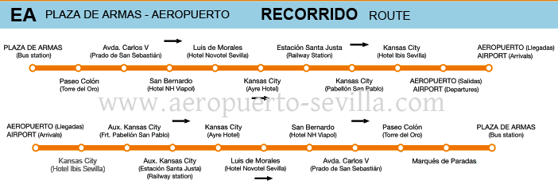
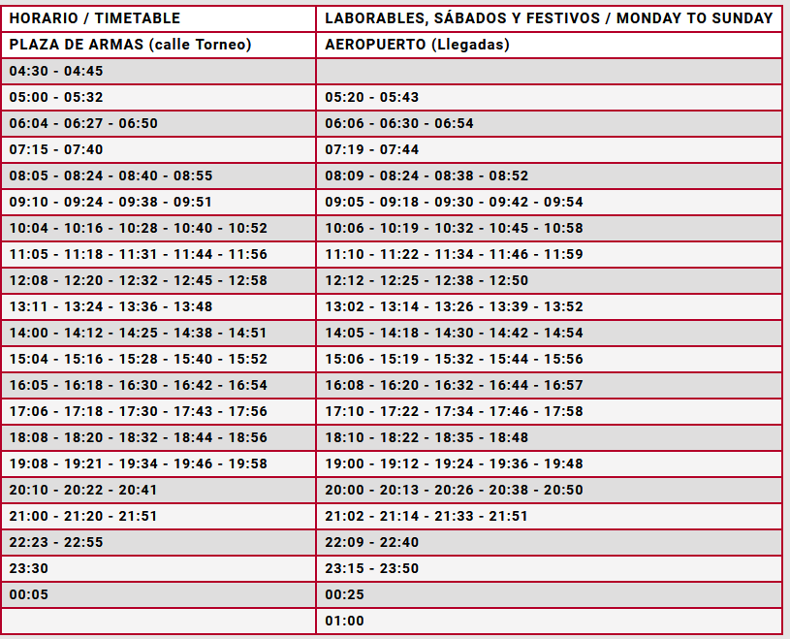
Public Bus
http://www.tussam.es/.

Taxis

If you need a taxi to pick you up, you may call to one of the numbers below:
Teletaxi: +34 954 62 22 22
Radiotaxi: +34 954 58 00 00
If you take a taxi from the airport to the city centre please note that there is a unique fare of approximately 25 euro.

IMPORTANT NUMBERS

International code 0034
Emergency: 112

CONTACT

If you need more information about the conference please go to our website: https://iri.jrc.ec.europa.eu/concordi-2023
For any additional question please do not hesitate to contact us. We are happy to help you!
Alina.MANGEA@ec.europa.eu
+34 95 44 88701

